**2024 CHE322 TERM PROJECT**

**PART-3**

In this assignment, you are asked **to design and evaluate the performance of three feedforward controllers**. We will designate C3 in the distillate as the primary controlled output variable, feed flow rate to the distillation column as the disturbance input variable to be measured (FC:SP), and reflux flow rate on a molar basis as the manipulated input variable (RFC:SP).

Refer to “ASPEN Plus Dynamics Manual Part III 2024” for the simulation and “FFC Design Notes” on some ideas on the design of feedforward controller.

For this assignment, you are asked to use the following design for FC, LC11, and LC12 namely:

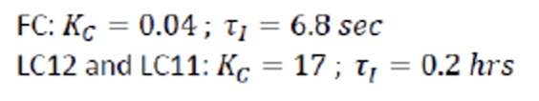

You are also asked to switch to using engineering units (from %) in the faceplates for FC and RFC.

1. Design and evaluate a gain-only feedforward controller, i.e.

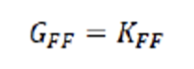

1. Design and evaluate a gain plus lead-lag feedforward controller, i.e

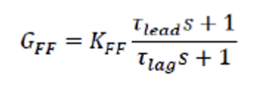

1. Design and evaluate a gain plus lead-lag plus deadtime feedforward controller, i.e.

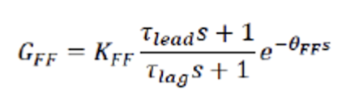

**General note: As a measure of the performance of your feedforward controllers, calculate the Integral Square Error (ISE) associated with the C3 molar composition of the distillate in relative to the desired value of 0.98. You are strongly encouraged to tune the controllers to optimize the performance i.e. the goal is to minimize the ISE.**

**Note for Q1-Q3: Ensure to describe the approach you took for coming up with the initial design of each controller and how you went about tuning each controller.**

1. Evaluate the performance of each of the three feedforward controllers, by only activating the *feedflowstep* task. You are asked to tune your controllers to optimize their performances for this task. Explain your results.
2. Evaluate the performance of each of the three feedforward controllers, by only activating the *feedcompstep* task. You are asked to tune your controllers to optimize their performances for this task. Explain your results.

**Report Format:**

* Each tutorial group is asked to prepare a single report answering the above questions. The title page must include the names of all group members, your tutorial section (Monday or Tuesday) and your group number.
* The second page must contain a summary of each student’s contribution to the report and signatures attesting to their contribution being original work.
* You can choose to structure your report in a Q/A format or use separate headings and add content. In either case, it is expected that you will answer all the questions with sufficient discussion.
* The page limit for the main body of the report is **10 pages**.
* Essential figures should be well integrated into the body of the report. Additional (less essential) figures may be included in the appendix (not included in the page limit). Please ensure that the content of your main body should be self-sufficient on its own.
* Use MS Word or Latex to write the report and use Python to produce your figures.
* Your report will be assessed based on the rubric provided in Quercus.

**Due Date:** **11th April 2024, 11:59 PM**

**Deliverables**: Submit **one PDF file** for the report and **one Python** (**.ipynb format only)** file including all required simulations and plotting. **Ensure to submit relevant excel files that your code needs to run**. Submit electronically on Quercus. Please name both your files in this format: “**Group-XX_Project_Part-3"** where XX is your group number.